**Aaryan Kapur**

**Computer Networks**

**Lab 6**

**E18CSE004**

**Q1**

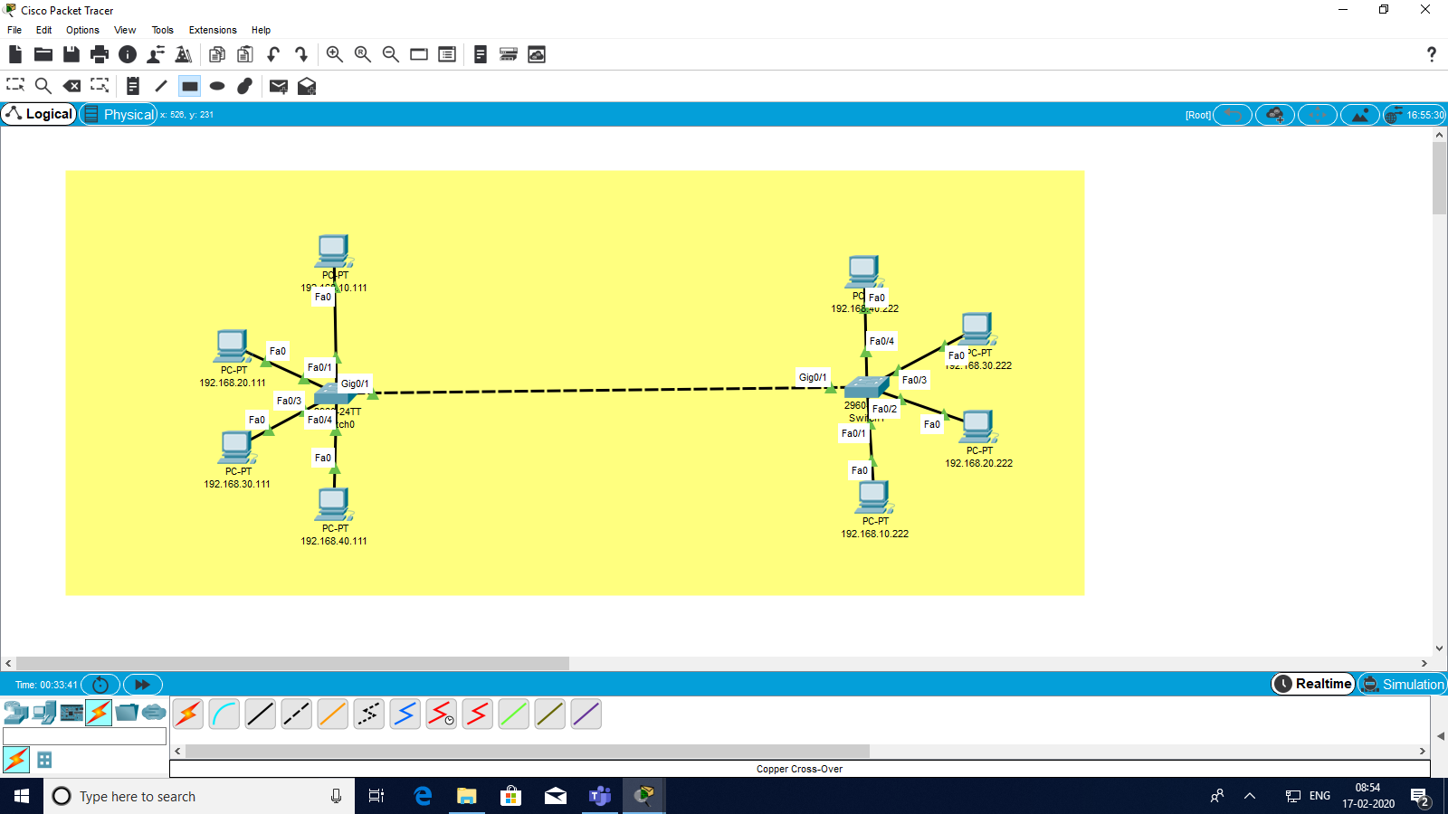

**Ip address scheme:**

Finance- vlan 100 Admin - vlan 200

Vlan 10 - 192.168.10.111 Vlan 10 - 192.168.10.222

Vlan 20 - 192.168.20.111 Vlan 20 - 192.168.20.222

Vlan 30 - 192.168.30.111 Vlan 30 - 192.168.30.222

Vlan 40 - 192.168.40.111 Vlan 40 - 192.168.40.222

**Commands**

***On switch 1***

Ena

Conf t

Vlan 100

Name finance

Exit

Int gigabitethernet0/1

Switchport mode trunk

Switchport nonegotiate

Exit

Int fa0/1

Switchport mode access

Switchport access vlan 10

Int fa0/2

Switchport mode access

Switchport access vlan 20

Int fa0/3

Switchport mode access

Switchport access vlan 30

Int fa0/4

Switchport mode access

Switchport access vlan 40

Do write memory

***On switch 2***

Ena

Conf t

Vlan 200

Name Admin

Exit

Int gigabitethernet0/1

Switchport mode trunk

Switchport nonegotiate

Exit

Int fa0/1

Switchport mode access

Switchport access vlan 10

Int fa0/2

Switchport mode access

Switchport access vlan 20

Int fa0/3

Switchport mode access

Switchport access vlan 30

Int fa0/4

Switchport mode access

Switchport access vlan 40

Do write memory

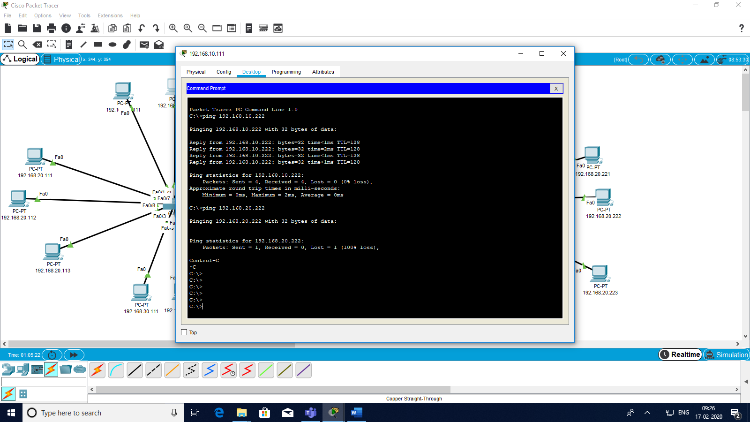

**Q2**

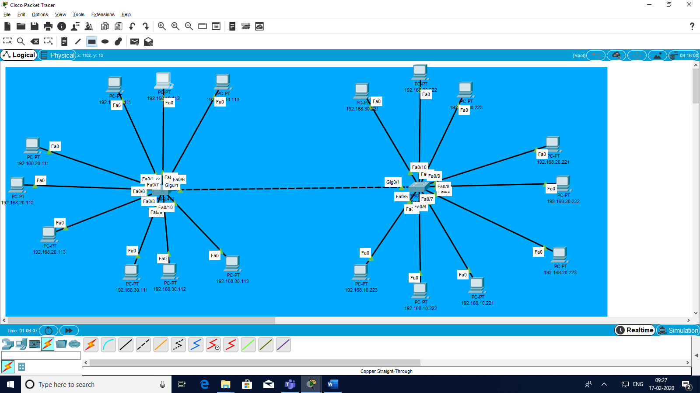

**Ip address scheme:**

Finance- vlan 100 Admin - vlan 200

Vlan 10 - 192.168.10.(111-113) Vlan 10 - 192.168.10.(221-223)

Vlan 20 - 192.168.20.(111-113) Vlan 20 - 192.168.20.(221-223)

Vlan 30 - 192.168.30.(111-113) Vlan 30 - 192.168.30.(221-223)

Vlan 40 - 192.168.40.(111-113) Vlan 40 - 192.168.40.(221-223)

**Commands**

***On switch 1***

Ena

Conf t

Vlan 100

Name finance

Exit

Int gigabitethernet0/1

Switchport mode trunk

Switchport nonegotiate

Exit

Int fa0/1

Switchport mode access

Switchport access vlan 10

Int fa0/5

Switchport mode access

Switchport access vlan 10

Int fa0/6

Switchport mode access

Switchport access vlan 10

Int fa0/2

Switchport mode access

Switchport access vlan 20

Int fa0/7

Switchport mode access

Switchport access vlan 20

Int fa0/8

Switchport mode access

Switchport access vlan 20

Int fa0/3

Switchport mode access

Switchport access vlan 30

Int fa0/9

Switchport mode access

Switchport access vlan 30

Int fa0/10

Switchport mode access

Switchport access vlan 30

Do write memory

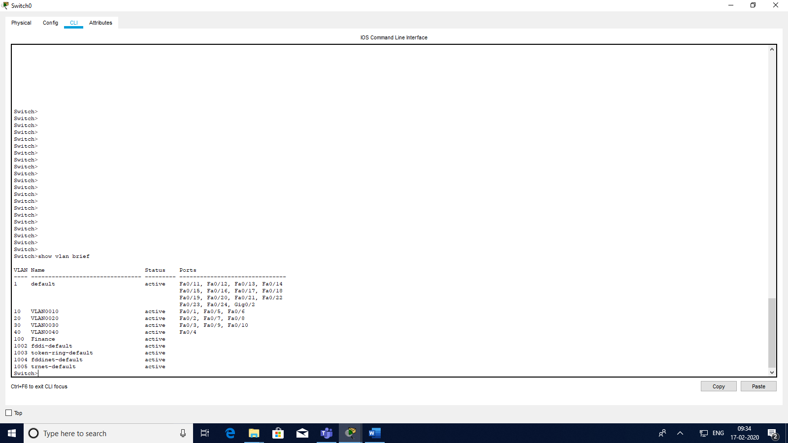

***On switch 2***

Ena

Conf t

Vlan 200

Name Admin

Exit

Int gigabitethernet0/1

Switchport mode trunk

Switchport nonegotiate

Exit

Int fa0/1

Switchport mode access

Switchport access vlan 10

Int fa0/5

Switchport mode access

Switchport access vlan 10

Int fa0/6

Switchport mode access

Switchport access vlan 10

Int fa0/2

Switchport mode access

Switchport access vlan 20

Int fa0/7

Switchport mode access

Switchport access vlan 20

Int fa0/8

Switchport mode access

Switchport access vlan 20

Int fa0/3

Switchport mode access

Switchport access vlan 30

Int fa0/9

Switchport mode access

Switchport access vlan 30

Int fa0/10

Switchport mode access

Switchport access vlan 30

Do write memory

